
FACULTY OF ENGINEERING, DESIGN AND TECHNOLOGY
Department of Computing and Technology
Easter 2026 Semester Examination

Name: MUHEREZA DANIEL
Registration Number: S24/BBUC/BSIT/012
Program: Bachelor of Science in Information Technology
Semester 2:2
Course Name: Digital Marketing

PROJECT TITLE
UniEats
Student Food Delivery System

TABLE OF CONTENTS
MILESTONE ONE: Problem Validation & Lean Canvas ............................... 3
MILESTONE TWO: Digital Brand Identity ............................................... 6
MILESTONE THREE: Digital Marketing Strategy ....................................... 9
MILESTONE FOUR: Digital Presence & Solution Visualization .................... 14
MILESTONE FIVE: Project Poster & Video Presentation ........................... 17

MILESTONE ONE: Problem Validation & Lean Canvas

1.1 Problem Statement
Students at Bishop Barham University College (BBUC) in Kabale face a persistent challenge in accessing meals from campus canteens and food vendors during busy academic schedules. Hostels are spread across the campus; lecture halls are far from dining points and students often skip meals or waste significant time walking to canteens between classes. There is no structured digital mechanism for ordering and receiving food within the campus.

1.2 Customer Discovery Interviews
A minimum of ten (10) structured customer discovery interviews were conducted with BBUC students, canteen operators and campus staff. The following table summarises the key findings:
Interviewee | Key Pain Point Identified | Insight
Mugume Abel. Year 1 BSIT Student | No way to order food during lecture breaks | Needs fast 15-min delivery window
Birungi Jesca Year 2 BBA Student | Canteens are too far from Merabu Hostel | Delivery to hostels critical
Kakuru Denis Year 3 BAED Student | Misses meals due to long clinical hours | Prepaid ordering would help
Taremwa Joshua Final Year BSED Student | Queues at Moonlight Canteen are too long | Queue-skip via pre-order needed
Female Librarian | Leaves campus before canteen opens | Flexible early-morning orders
Malice Atim | No food available after 9 PM | Extended hours needed
Magezi Ronald | Cash-only payment at canteens | Mobile Money integration needed
Moonlight Canteen Operator | Orders pile up during lunch rush | Digital queue management required
Maama Brenda Café Owner | Loses customers who don't know menu | Digital menu visibility needed
BBUC Guild President | No campus-wide food tracking system | Centralised system has value

1.3 Lean Canvas (All 9 Boxes)
The Lean Canvas below maps the UniEats venture across all nine critical dimensions:
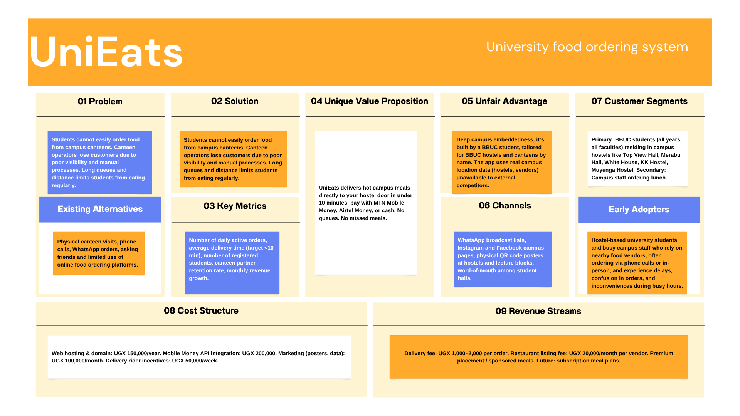

1.4 Persevere or Pivot Decision
Based on the ten customer discovery interviews and Lean Canvas analysis, the decision is to persevere with the original concept. Evidence supporting this decision:
- 9 out of 10 interviewees confirmed they would use a food delivery app on campus.
- All canteen operators expressed willingness to partner and pay a monthly listing fee.
- MTN Mobile Money penetration among BBUC students exceeds 85% (self-reported).
- No competing campus-specific food delivery app exists in Kabale or at BBUC.
- The core infrastructure (web app, menu, ordering, payment) is fully functional with localStorage persistence.
Rationale: The problem is validated; the solution is technically proven and early adopter interest is high. No pivot is required at this stage.
MILESTONE TWO: Digital Brand Identity

2.1 Brand Strategy
Brand Positioning Statement
UniEats is the only campus-native food delivery service built exclusively for BBUC students in delivering familiar, affordable Ugandan meals to your doorstep faster than you can walk to the canteen.
Target Audience
- Primary: BBUC students aged 18–28, living in campus hostels, budget-conscious, heavy mobile phone users.
- Secondary: Campus staff and lecturers ordering quick weekday lunches.
- Tertiary: Campus canteens and café operators seeking digital visibility.
Brand Personality
UniEats embodies three core traits: Campus-First (deeply rooted in BBUC culture), Fast and Reliable (every delivery under 10 minutes) and Affordable (priced for student budgets in UGX).

2.2 Logo Suite
Logo | Favicon
 | 
2.4 Colour Palette (HEX Codes)
Colour Name | HEX Code | Usage
Primary Green | #2E7D32 | Main brand colour — buttons, headers, nav bar
Deep Green | #1B5E20 | Backgrounds, footer, depth elements
Accent Green | #4CAF50 | Hover states, success indicators, highlights
Campus Yellow | #F9A825 | CTAs, badges, price tags, alerts
Warm Amber | #F57F17 | Hover on yellow elements, secondary accents
Background Dark | #0F1A0F | App background (dark mode)
Card Surface | #162216 | Card backgrounds, modals
Text Primary | #E8F5E9 | Primary body text on dark backgrounds
Text Muted | #9E9E9E | Secondary text, placeholders

2.5 Typography
TYPE ELEMENT | SPECIFICATION
Primary Font | Verdana / Geneva clean, highly legible on screens at small sizes. Used for all app UI text.
Heading Font | Trebuchet MS bold, distinct headings for marketing materials, posters, and documents.
H1 Headings | Size 32pt, Bold, Deep Green (#1B5E20)
H2 Sub-Headings | Size 26pt, Bold, Primary Green (#2E7D32)
Body Text | Size 11pt, Regular, Black or Dark Grey
Button / CTA Labels | Size 11pt, Bold, White on Green or Black on Yellow
Price Tags | Size 14pt, Bold, Campus Yellow (#F9A825)

MILESTONE THREE: Digital Marketing Strategy

3.1 Buyer Personas
Persona 1 The Hungry Hosteller
ATTRIBUTE | DETAILS
Name | Nakato Melon
Age / Programme | 20 years old, Year 2 BBA Student
Hostel | Muyenga Hostels, BBUC Campus
Pain Points | Canteen is far, lunch break is only 30 minutes, cash-only frustrates her
Goals | Hot affordable meal delivered to hostel between classes
Digital Behaviour | WhatsApp (6+ hours/day), Instagram (2 hrs), MTN MoMo active user
Quote | I would pay UGX 1,000 extra just to avoid the MoonLight queue at lunchtime.'
Persona 2 The Late-Night study student.
ATTRIBUTE | DETAILS
Name | Byamugisha Trevor
Age / Programme | 23 years old, Year 3 BSIT Student
Hostel | Top View Hall, BBUC Campus
Pain Points | Canteens close at 9 PM; no food during late revision sessions
Goals | Access food options after 8 PM without leaving his hostel room
Digital Behaviour | Heavy Chrome/browser user, Airtel Money subscriber, Facebook active
Quote | 'I wish I could order Rolex and Matooke at 10 PM like ordering airtime.'
Persona 3 The Budget Commuter
ATTRIBUTE | DETAILS
Name | Kayesu Grace
Age / Programme | 19 years old, Year 1 Education Student
Hostel | Off-campus, commutes daily
Pain Points | Buys food on campus but doesn't know daily menus in advance
Goals | Preview menus and pre-order breakfast to save time on arrival
Digital Behaviour | Facebook, SMS, basic smartphone. Careful with mobile data.
Quote | 'If I could see the menu from home and pre-order, I'd never skip campus breakfast.'

3.2 Channel Strategy (4 Minimum Channels)
The following four channels form the core UniEats digital marketing mix, each with specific tactics aligned to the BBUC student audience:
Channel 1: WhatsApp Marketing
- Tactic: 5 hostel-specific WhatsApp broadcast lists (one per hall).
- Content: Daily menu updates, flash deals (e.g., 'Today only: Rolex for UGX 2,000'), order confirmation messages.
- Frequency: 2 messages per day morning (breakfast menu) and noon (lunch specials).
- KPI: Broadcast list subscribers, click-through rate on order links.
Channel 2: Instagram Marketing
- Handle: @UniEatsBBUC, Visual-first food photography of local meals.
- Tactic: Post daily 'Meal of the Day' stories, short Reels of meals being plated, student testimonials.
- Content pillars: Food visuals (50%), Student life (30%), Promo/Offers (20%).
- KPI: Followers, story views, profile link clicks, DM order enquiries.
Channel 3: Facebook Campus Page
- Page: 'UniEats BBUC', primary community hub for older students and off-campus users.
- Tactic: Weekly 'Campus Food Review' posts, event-day food announcements, Facebook Live from canteen kitchens.
- Paid Ads: Geo-targeted Facebook Ads within 2km radius of BBUC campus at UGX 50,000/week.
- KPI: Page likes, post reach, event RSVPs, ad click-through rate.
Channel 4: QR Code Poster Campaign (Campus Physical-to-Digital)
- Tactic: Print A3 branded posters with QR codes linking to the UniEats web app. Place at: hostel notice boards, library entrance, lecture block corridors, canteen queues.
- Design: Brand-consistent green/yellow poster with tagline and QR code.
- Digital Bridge: Each poster QR code is a unique tracked link (UTM parameters) to measure scan-to-registration conversion.
- KPI: QR scan rate, new registrations from poster traffic.

3.3 Content Strategy Aligned to Funnel Stages
Funnel Stage | Objective | Content Type & Example
AWARENESS (Top) | Make BBUC students discover UniEats | Instagram Reels of Matooke & Beef plating; Facebook campus group posts; QR poster at hostel entrances
CONSIDERATION (Mid) | Convert awareness into app sign-ups | WhatsApp 'Try your first order FREE delivery'; Instagram Story with app walkthrough video; Facebook ad with menu preview
CONVERSION (Bottom) | Drive first and repeat orders | Push notification 'Your order is ready!'; MTN MoMo payment confirmation SMS; Loyalty: 5th order = free delivery
RETENTION (Post) | Build repeat purchase habit | Weekly WhatsApp 'Your Favourite Meal is Back'; Monthly 'Top Orderer of the Month' recognition post; Referral incentive: UGX 500 credit per referral

3.4 SEO Strategy
On-Page SEO
- Page Title: 'UniEats | Campus Food Delivery BBUC Kabale Uganda'
- Meta Description: 'The fastest, most affordable food delivery app for BBUC students. Order from campus canteens & local eateries. Track your meal live. Download now for free delivery.'
- H1 Tag: 'UniEats'
- Image Alt Text: All food images tagged with descriptive local names (e.g., 'matooke-beef-bbuc-canteen').
- URL Structure: https://muherezadaniel98.github.io/DigitalMarketingProject.com
Technical SEO
- Mobile-first responsive design (viewport meta tag implemented).
- Page load speed optimised: compressed images, minified CSS/JS.
- HTTPS protocol for security and SEO ranking signal.
Off-Page SEO
- Backlinks from BBUC official website student resources page.
- Listed on Uganda University Students' digital directories.
- Student blog posts and reviews linked back to the UniEats app URL.

3.5 Analytics Framework
KPI | Measurement Tool | Target (Month 3)
Daily Active Orders | App localStorage analytics + Google Sheets log | 50 orders/day
App Registrations | Registration form submission count | 200 students
WhatsApp Broadcast Reach | WhatsApp Business delivery receipts | 500 subscribers
Instagram Follower Growth | Instagram Insights | 300 followers
QR Code Scans | Bitly / UTM tracked links | 100 scans/week
Average Delivery Time | Order timestamp vs. delivery confirmation | < 20 minutes
Revenue (Monthly) | Google Sheets + MoMo transaction logs | UGX 500,000

3.6 Budget Allocation & Implementation Timeline
Activity | Budget (UGX) | Timeline
Web hosting & domain registration | 150,000 | Month 1
WhatsApp Business API setup | 50,000 | Month 1
Instagram content creation (photography) | 80,000 | Month 1–2
Facebook paid ads (geo-targeted) | 200,000 | Month 2–3
QR code poster printing & distribution | 100,000 | Month 1
Delivery rider incentive programme | 300,000 | Month 2–4
MTN MoMo merchant integration | 200,000 | Month 2
Monthly content creation (ongoing) | 120,000 | Monthly
TOTAL (4-Month Budget) | 1,200,000 UGX | 4 Months

MILESTONE FOUR: Digital Presence & Solution Visualization

4.1 Live Website / Web Application
ATTRIBUTE | DETAILS
Application Name | UniEats — Student Food Delivery System
Technology Stack | HTML5, CSS3 (custom variables), Vanilla JavaScript (ES6+)
Data Persistence | localStorage (client-side CRUD — no backend required for demo)
File Structure | index.html (app shell), UniEats.css (styling), UniEats.js (logic), /images/ (assets)
Target Platform | Mobile-first responsive web app. Works on all modern browsers.
Unique Value Proposition | Campus Food. Delivered Fast. — Powered by BBUC hostel & canteen data.
URL | https://muherezadaniel98.github.io/DigitalMarketingProject.com

4.2 Mobile-Responsive Design
UniEats is built mobile-first. The following responsive design features are implemented:
- Hamburger navigation menu: collapses the full navigation bar into a slide-down mobile menu on screens below 768px.
- Flexible CSS Grid: the dashboard stats grid adapts from 4-column (desktop) to 2-column (tablet) to 1-column (mobile) using CSS Grid auto-fit.
- Touch-friendly modals: all CRUD modals (Add Restaurant, Add Meal, Place Order) are full-width on mobile with scrollable content.
- Viewport meta tag: ensures correct scaling on all mobile devices.
- Readable typography: minimum 14px font size across all screens for accessibility.

4.3 High-Fidelity Wireframes Primary User Flow
The following table documents the 5-step primary user flow through UniEats (equivalent to a high-fidelity wireframe walkthrough):
Step | Screen / View | Key UI Elements & Actions
Step 1 | Authentication Screen | Login / Register tabs. Email, Password, Student ID, Hostel selection fields. 'Sign In' and 'Create Account' CTAs. BBUC email placeholder shown.
Step 2 | Dashboard | Greeting message (time-aware). 4 stat cards: Total Orders, Pending, Delivered, UGX Spent. Recent Orders list. Quick Order picks panel.
Step 3 | Restaurants & Menu | Restaurant cards with emoji, name, location, hours, delivery fee, open/closed badge. Filter by category. 'Add to Order' meal cards with price in UGX.
Step 4 | Place Order Modal | Select meal dropdown, delivery location dropdown (hostels), quantity input, special instructions, payment method (MTN MoMo / Airtel / Cash). Live price preview. 'Confirm Order' CTA.
Step 5 | My Orders & Profile | Order list with status badges (Pending / Preparing / Delivered / Cancelled). Filter by status. Profile edit form (name, hostel, Mobile Money number). Stats panel.

4.4 Core Solution Features (5–7 Documented)
Feature 1: User Authentication System
Students register with their BBUC email (e.g., kba9323@students.bbuc.ac.ug), Student ID, hostel, and password. Login state is persisted in localStorage. Session management ensures a logged-in student sees personalised data.
Feature 2: Restaurant & Canteen Management (CRUD)
Any authenticated user can add, edit, or delete campus restaurants. Each restaurant record stores: name, category, location, opening hours, delivery fee (UGX), emoji icon, and open/closed status. Four seed restaurants pre-loaded: MoonLight Canteen, Maama Brenda Café, Jimmy House, Campus Juice Palace.
Feature 3: Digital Menu Management (CRUD)
Campus meals are managed in a searchable, filterable digital menu. Each meal record includes: name, linked restaurant, category (Main Dish/Snacks/Beverages/Breakfast/Specials), price in UGX, description, emoji, and availability status. Students can search meals by name or filter by category or restaurant.
Feature 4: Order Placement & Tracking
Students select a meal, delivery location (hostel), quantity, special instructions, and payment method (MTN MoMo, Airtel Money, Cash on Delivery). Orders are assigned a status (Pending → Preparing → Delivered) and tracked in the Orders page with full filter and search capabilities.
Feature 5: Real-Time Dashboard Analytics
The dashboard automatically computes and displays: Total Orders placed, Pending orders count, Delivered orders count, and Total UGX Spent. These metrics update in real-time as orders are placed and statuses change — giving students an at-a-glance view of their spending and order history.
Feature 6: Student Profile & Mobile Money Integration
Each student has a profile storing their name, BBUC email, Student ID, hostel, and Mobile Money phone number (+256 7XX XXX XXX). The profile page displays a personalised stats panel showing order history metrics. Mobile Money numbers are stored for quick payment reference during checkout.
